# Medical Device Inventory Management

## Project/problem Overview

With the widespread spread of COVID-19, medical devices like Ventilator, equipment, such as Monitor medical equipment and tools such as protective gear, clothing and gloves that clinicians use to deliver patient care, have become increasingly scarce.

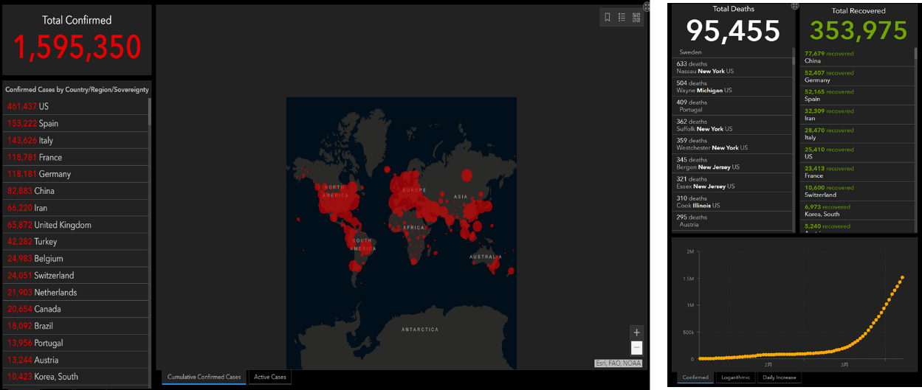

Figure COVID-19

In addition, many medical devices are extremely complex and expensive to buy and expensive to maintain. However, they are crucial to patient safety. This program aim to develop effective ways of utilizing their expensive medical equipment. We want to share expensive equipment in their service provider network, such as a hospital or a supplier company. Therefore, there is no need to purchase expensive equipment that is not often used. In addition, good management of equipment utilization can have an impact on clinical operations, such as surgery, which are heavily dependent on the availability of medical equipment. In other words, good management of equipment inventory means efficient use of the operating room and efficient use of clinician time and staff time.

Obviously, the effective management of medical equipment can improve the utilization rate of medical resource. At the same time, make medical establishment more efficiently and effectively by reduce unnecessary work.

**Proposed Entities**

1. System
2. Network
3. Enterprise: Enterprise detailed information

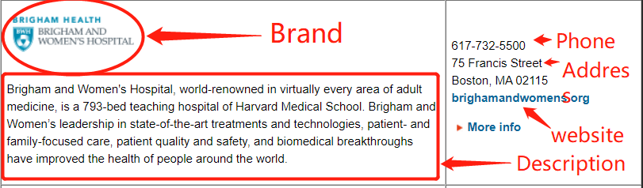

Hospital: hospital like Brigham and Women's Hospital, Massachusetts General Hospital, etc.

Supplier: supplier include many hospitals and other medical products and services provider like AllWays Health Partners(health insurance) .

1. Organization:

* Medical department: MD&DO who can apply a clinical operations and become the leader of a care team.



Figure MD

NP&APRN who can become the member of care team.



Figure NP

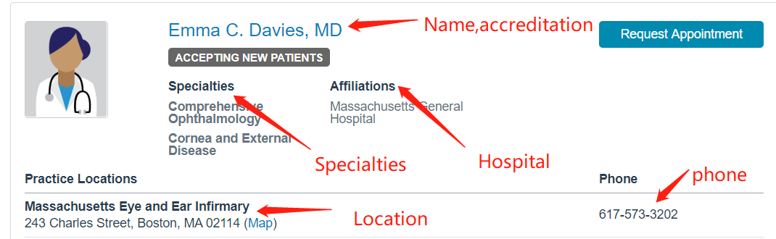

* Inventory department: Warehouse manager
* Financial department: Accountant

## Application Key Functionalities

**Network Staff**/**Hospital Admin**/**Organization Admin:**

1. Create new entities
2. Allocate account and password

### Doctor:

1. Create schedule of clinical procedures
2. View all surgery scheduling
3. View time table of medical device and other detailed information of device
4. View time table of room
5. Search available room and medical device
6. Sort medical device by name and other features

### Nurse:

1. Join care team of the clinical procedure
2. View themselves’ scheduling time table

### Warehouse manager

1. Create schedule of required medical device according to the clinical procedures created by doctor.
2. View time table of medical device and other detailed information of device
3. Sort medical device by name and other features

### Accountant

1. View payment history
2. Send / receive funds

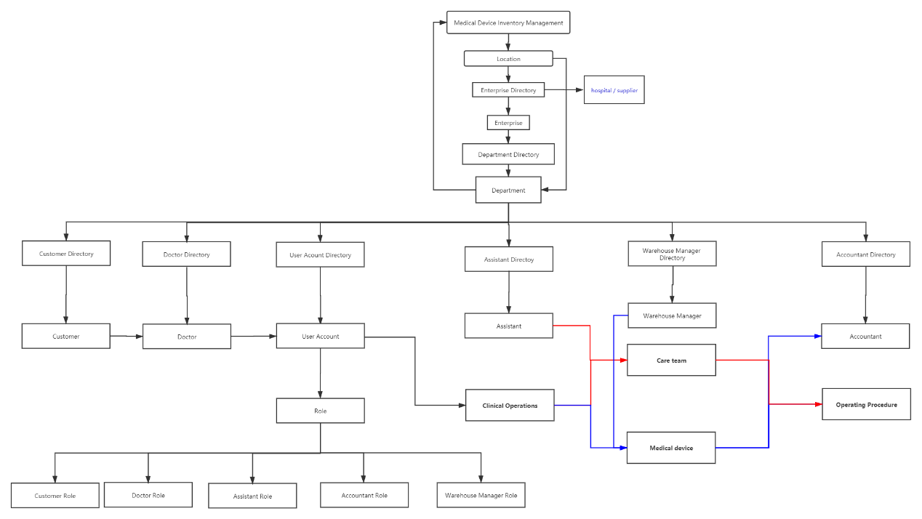

Figure Outer Layer

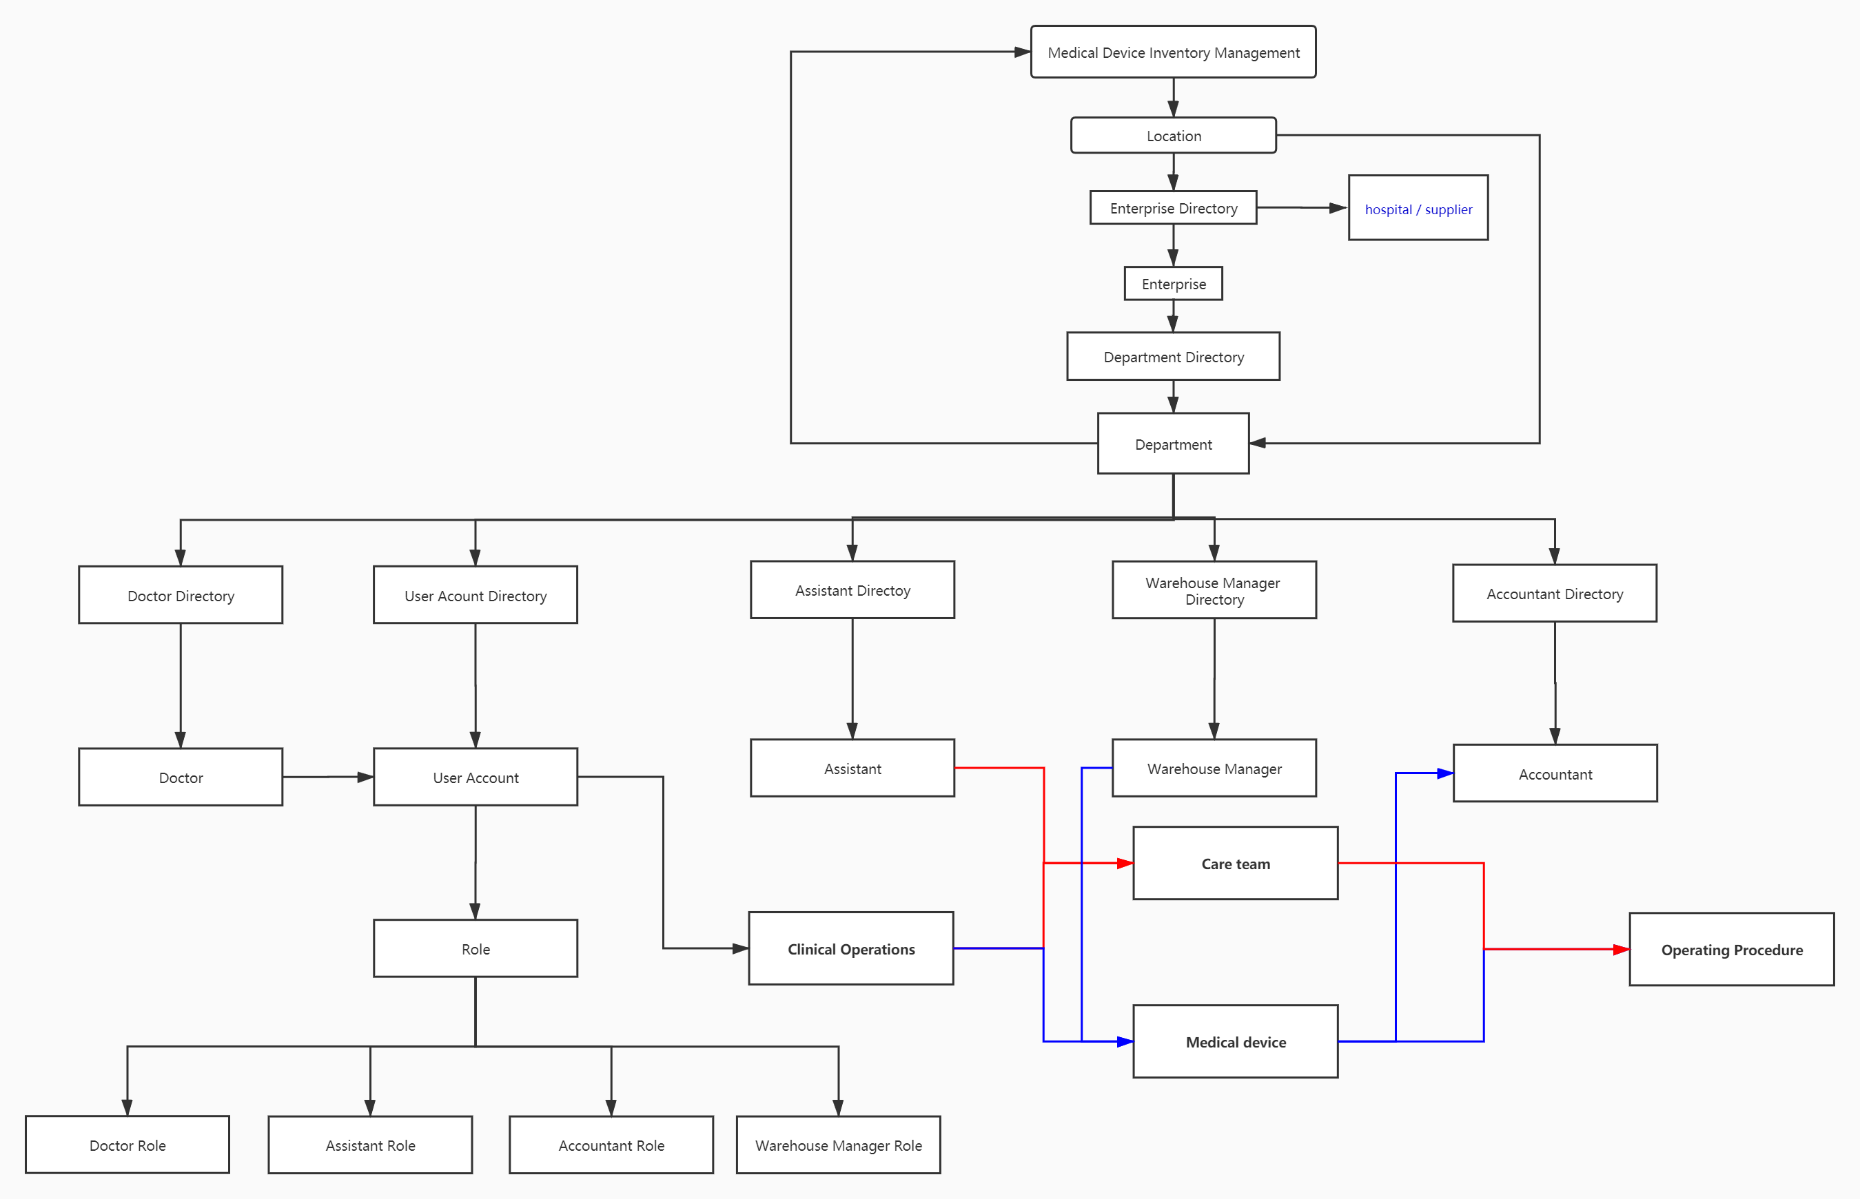

Figure Inner Layer

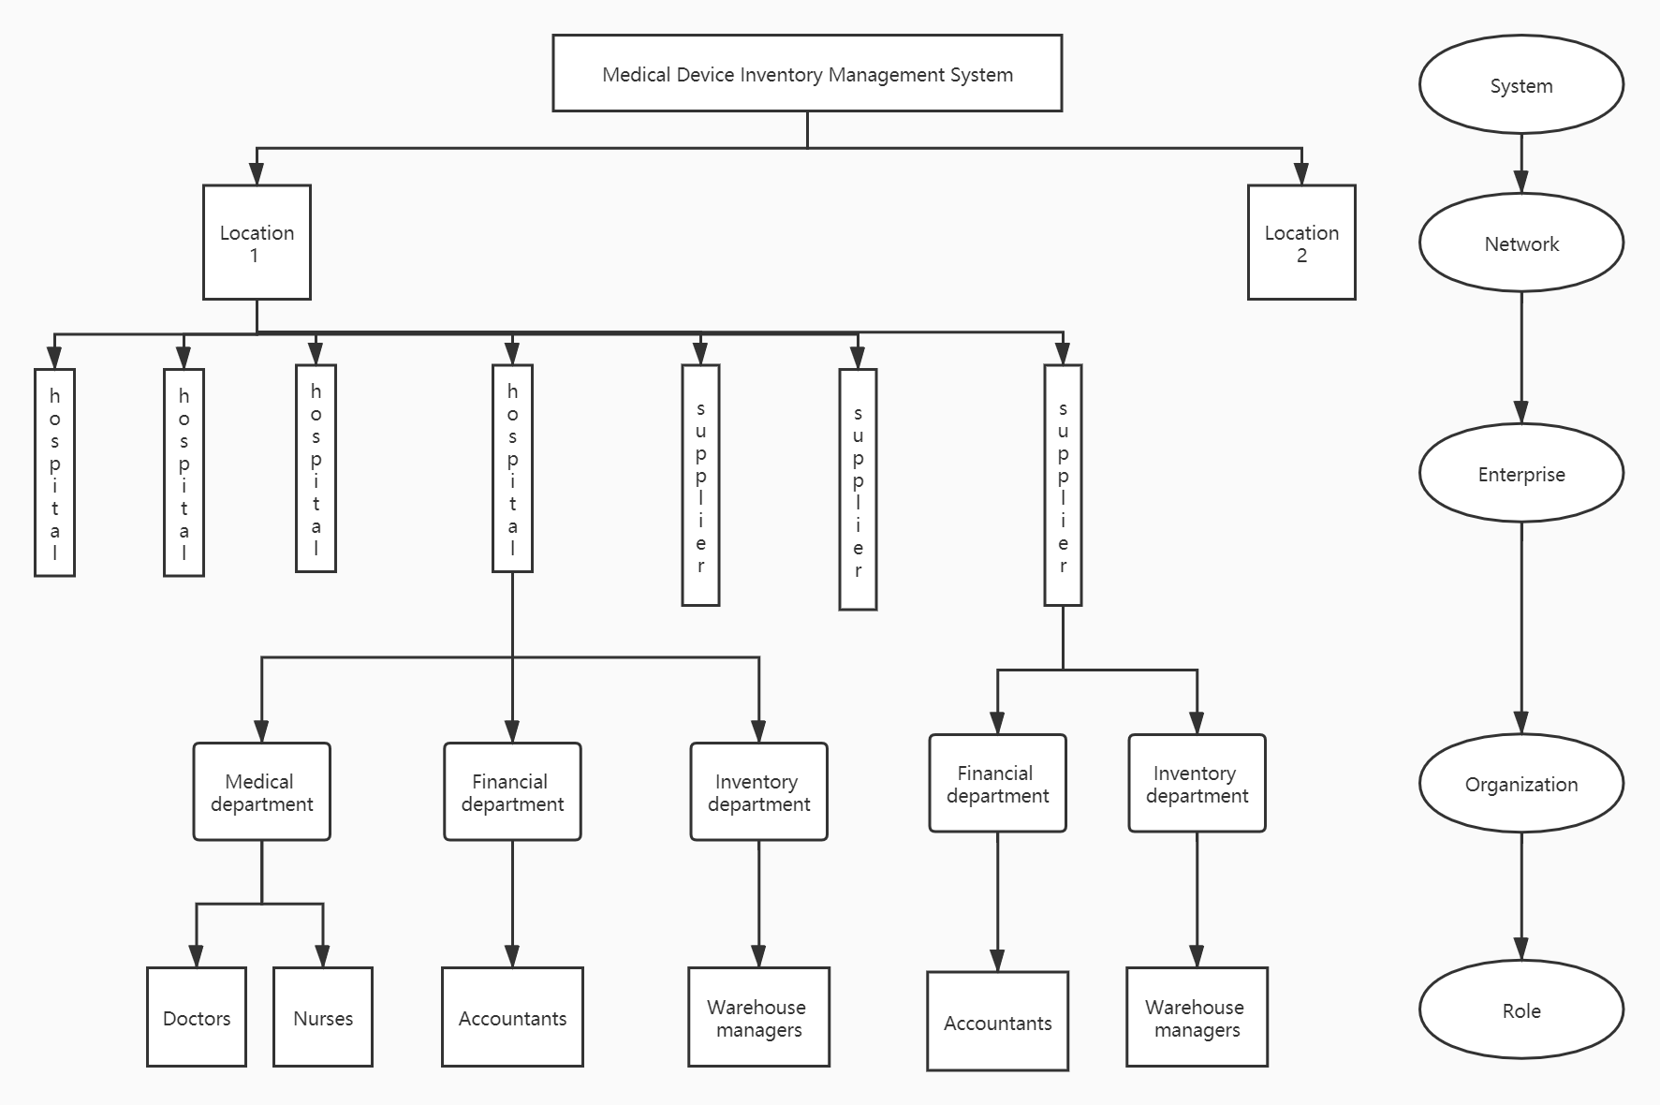

Figure Hierarchical structure of ecosystem